

**车载蓝牙电话主观测试报告**

## 1.主观测试的测试点

### 噪声 Noise

通话过程中，近端和远端受整车内外环境影响或主机自身问题引起的异常噪音。

### 回音 Echo

通话过程中，远端能听到反弹回来的声音，例如“1”、“啊”等。

### 辨识度 Understanding

可根据通话声音辨别出说话者。

### 双向通话 Double Talk

### 近端和远端同时讲话，能辨清语句, 没有噪声和回声，没有丢字，卡字，声音流畅。

## 3.评价指标

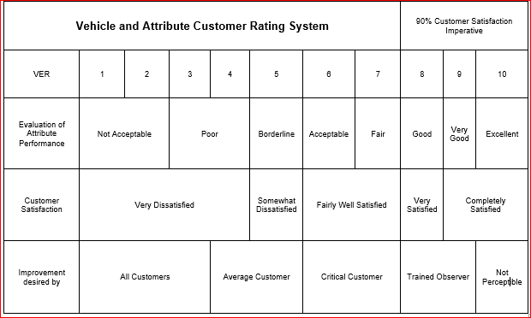

最低平均分为8分

Excellent：很好（无任何杂音，无回音，辨识度和双向通话好，无丢字，卡字现象）

Very Good：比较好（基本无杂音，回音，辨识度和双向通话好，无丢字，卡字现象）

Good：还行（轻微无杂音，回音，辨识度和双向通话好，无丢字，卡字现象）

Fair：一般 （有杂音，回声，有轻微卡字现象，通话效果勉强接受）

Acceptable：刚好能通话（有杂音，有回音，还是不能辨识声纹，，丢字，卡字，影响正常通话）

Borderline：压线（明显杂音和回音，能勉强辨析通话内容，，丢字，卡字，影响正常通话）

Poor：较差（有明显杂音和回音，基本辨识不了声纹，丢字，卡字，影响正常通话）

Not Acceptable: 不可接受（不能正常通话）

实际测试结果

1.近端手机型号（ , ）; 远端手机型号及测试人员名称（ , ）

|  |  |  |  |  |  |  |  |  |  |
| --- | --- | --- | --- | --- | --- | --- | --- | --- | --- |
| 车载蓝牙电话主观测试评分表 | | | | | | | | | |
| 场景 | 通话音量24 | | | 通话音量18 | | | 通话音量12 | | |
| 空调风量7 | 空调风量5 | 空调风量3 | 空调风量7 | 空调风量5 | 空调风量3 | 空调风量7 | 空调风量5 | 空调风量3 |
| 双方都不讲话 |  |  |  |  |  |  |  |  |  |
| 近端单讲 |  |  |  |  |  |  |  |  |  |
| 远端单讲 |  |  |  |  |  |  |  |  |  |
| 双讲 |  |  |  |  |  |  |  |  |  |
|  |  |  |  |  |  |  |  |  |  |

2. 近端手机型号（ , ）; 远端手机型号及测试人员名称（ , ）

|  |  |  |  |  |  |  |  |  |  |
| --- | --- | --- | --- | --- | --- | --- | --- | --- | --- |
| 车载蓝牙电话主观测试评分表 | | | | | | | | | |
| 场景 | 通话音量24 | | | 通话音量18 | | | 通话音量12 | | |
| 空调风量7 | 空调风量5 | 空调风量3 | 空调风量7 | 空调风量5 | 空调风量3 | 空调风量7 | 空调风量5 | 空调风量3 |
| 双方都不讲话 |  |  |  |  |  |  |  |  |  |
| 近端单讲 |  |  |  |  |  |  |  |  |  |
| 远端单讲 |  |  |  |  |  |  |  |  |  |
| 双讲 |  |  |  |  |  |  |  |  |  |
|  |  |  |  |  |  |  |  |  |  |

3. 近端手机型号（ , ）; 远端手机型号及测试人员名称（ , ）

|  |  |  |  |  |  |  |  |  |  |
| --- | --- | --- | --- | --- | --- | --- | --- | --- | --- |
| 车载蓝牙电话主观测试评分表 | | | | | | | | | |
| 场景 | 通话音量24 | | | 通话音量18 | | | 通话音量12 | | |
| 空调风量7 | 空调风量5 | 空调风量3 | 空调风量7 | 空调风量5 | 空调风量3 | 空调风量7 | 空调风量5 | 空调风量3 |
| 双方都不讲话 |  |  |  |  |  |  |  |  |  |
| 近端单讲 |  |  |  |  |  |  |  |  |  |
| 远端单讲 |  |  |  |  |  |  |  |  |  |
| 双讲 |  |  |  |  |  |  |  |  |  |
|  |  |  |  |  |  |  |  |  |  |

4. 近端手机型号（ , ）; 远端手机型号及测试人员名称（ , ）

|  |  |  |  |  |  |  |  |  |  |
| --- | --- | --- | --- | --- | --- | --- | --- | --- | --- |
| 车载蓝牙电话主观测试评分表 | | | | | | | | | |
| 场景 | 通话音量24 | | | 通话音量18 | | | 通话音量12 | | |
| 空调风量7 | 空调风量5 | 空调风量3 | 空调风量7 | 空调风量5 | 空调风量3 | 空调风量7 | 空调风量5 | 空调风量3 |
| 双方都不讲话 |  |  |  |  |  |  |  |  |  |
| 近端单讲 |  |  |  |  |  |  |  |  |  |
| 远端单讲 |  |  |  |  |  |  |  |  |  |
| 双讲 |  |  |  |  |  |  |  |  |  |
|  |  |  |  |  |  |  |  |  |  |

5. 近端手机型号（ , ）; 远端手机型号及测试人员名称（ , ）

|  |  |  |  |  |  |  |  |  |  |
| --- | --- | --- | --- | --- | --- | --- | --- | --- | --- |
| 车载蓝牙电话主观测试评分表 | | | | | | | | | |
| 场景 | 通话音量24 | | | 通话音量18 | | | 通话音量12 | | |
| 空调风量7 | 空调风量5 | 空调风量3 | 空调风量7 | 空调风量5 | 空调风量3 | 空调风量7 | 空调风量5 | 空调风量3 |
| 双方都不讲话 |  |  |  |  |  |  |  |  |  |
| 近端单讲 |  |  |  |  |  |  |  |  |  |
| 远端单讲 |  |  |  |  |  |  |  |  |  |
| 双讲 |  |  |  |  |  |  |  |  |  |
|  |  |  |  |  |  |  |  |  |  |

6.近端手机型号（ , ）; 远端手机型号及测试人员名称（ , ）

|  |  |  |  |  |  |  |  |  |  |
| --- | --- | --- | --- | --- | --- | --- | --- | --- | --- |
| 车载蓝牙电话主观测试评分表 | | | | | | | | | |
| 场景 | 通话音量24 | | | 通话音量18 | | | 通话音量12 | | |
| 空调风量7 | 空调风量5 | 空调风量3 | 空调风量7 | 空调风量5 | 空调风量3 | 空调风量7 | 空调风量5 | 空调风量3 |
| 双方都不讲话 |  |  |  |  |  |  |  |  |  |
| 近端单讲 |  |  |  |  |  |  |  |  |  |
| 远端单讲 |  |  |  |  |  |  |  |  |  |
| 双讲 |  |  |  |  |  |  |  |  |  |
|  |  |  |  |  |  |  |  |  |  |